13.73: The pendulum swings through cycle in 1.42 s, so 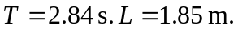
Use T to find g:
Use g to find the mass 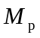of Newtonia:
